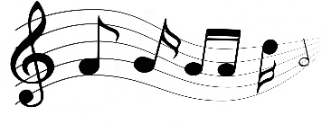
“I keep a close watch on this heart of mine.”
This Photo by Unknown Author is licensed under CC BY
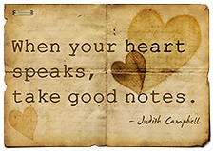
The “If” Series—Lesson 7
Sherry and I recently went on vacation to be with some aging family members as we lived and breathed “good times.” We are all getting older by the minute (duh!) and feel it is necessary to enjoy ourselves with family before apathy, grouchiness, moodiness, hard-headiness, etc. sets in (just kidding)!
We went to the “Senior Haven of America” in Branson, Missouri. Many yesteryear stars of the 50’s through the 70’s were well represented in the 100 plus shows/entertainment appearing at the many auditoriums/venues of the city. Of course, there are other present-day stars in the country music field who appeal to all age groups in order to keep bringing in customers and some “idle worshippers” all over the world.
I was especially intrigued with a particular group of entertainers who imitated the country music stars of our time. One of the stars who was imitated was Johnny Cash (the guy did a great job of sounding like “the man in black”).
As always, I listened to the words more than the music and rhythm of the band. Words say a lot…music just helps the words sound inviting and entertaining…and sometimes we find our feet tapping to the rhythm of the band.
You have heard the song by Johnny Cash, “I’ll Walk the Line.” The first words of the song say a lot…
“I keep a close watch on this heart of mine.” The 2nd line is just as important… “I keep my eyes wide open all the time.”
What a line for a devotion! What a statement a Christian should make as he travels this trail called life.
With that…Let me branch out into my 7th and final lesson in the “IF” series.
“If you want to be like Jesus…listen to His heart beating within you!”
The Bible has a lot to say about the heart. Most of the time it is referring to the inner self, the character part of one’s being, and/or the inward thoughts that thinks, decides, and senses right from wrong. It is the center…not only of spiritual activity, but of all the operations of human life.

Matthew 22:37, “Jesus replied: “‘Love the Lord your God with all your heart and with all your soul and with all your mind.”
As human beings we know we have a physical heart. But, if we have any intelligence at all, we are aware that we also have something within us that we recognize as an intangible heart.
What exactly is this intangible heart? We’ve heard the word heart used since we were young, in everyday language, in literature, in music, and in other contexts. Most of us probably have a general definition of the heart…thinking of it as something inside us that feels emotions like love, affection, compassion, or even sorrow.
The definition of the heart in the Bible isn’t given in one verse; the definition is spread throughout many verses and can be easily missed if we don’t rightly divide the Word of truth.
Since the Bible refers to the heart hundreds of times, it must be significant to God and to us.
So what does the Word of God say about our heart?
If we really want to know we must ask ourselves, “What is the heart’s importance to God and to us?
The true heart is nothing but true consecration of our wills…It is the spirit within us saying to the Spirit who lives in us, “I long to live wholly for God and I am willing to gladly give up everything and live wholly for Him.”
True religion is an inward life (one’s heart) living in the power of the Holy Spirit.

The importance of knowing about our heart
As we search the definition of heart online, we will find all kinds of photos and diagrams of the physical heart explaining in detail its function and the way it works.
You’ll also find a lot of information on caring for it so you can live longer. A poor diet, lack of exercise, and other factors can have negative consequences.
But what about the condition of our intangible heart?
If neglecting our physical heart affects our life negatively, then surely neglecting our intangible heart is also detrimental.
But how can we care for our heart if we don’t know what it is?
Well, let’s discuss what our heart is, not according to our common understanding, but according to the Bible. This will help us to properly care for our heart in our life with the Lord.

What does the Bible say our heart is? Our “intangible heart” in the Bible is a composition of all the components of our soul—our mind, emotion, and will—plus the most important part of our spirit—our conscience.
Matthew 9:4, “And Jesus, knowing their thoughts, said, Why are you thinking evil things in your hearts?”
Thinking is something of the mind, but the Lord Jesus asked the scribes why they were thinking (evil things) in their hearts. This shows that our mind is part of our heart.
Acts 11:23, “Who, when he arrived and saw the grace of God, rejoiced and encouraged them all to remain with the Lord with purpose of heart.”
To purpose means to decide strongly to do something, to use our will. Therefore, this verse shows that our will is part of our heart.
John 16:22, “Therefore you also now have sorrow; but I will see you again and your heart will rejoice, and no one takes your joy away from you.”
We rejoice with our emotions, and here we see that our heart rejoices. Thus, it shows us that our emotion(s) is part of our heart.
Hebrews 10:22, “Let us come forward to the Holy of Holies with a true heart in full assurance of faith, having our hearts sprinkled from an evil conscience and having our bodies washed with pure water.”
We see in this verse that our conscience is part of our heart. This is further confirmed by the phrase “if our heart blames us” in 1 John 3:20. Since our conscience is what blames or condemns us when we’re wrong, this verse makes it abundantly clear that our conscience is part of our heart.
So according to the Bible, our heart is not simply something we feel emotion with. Because it’s composed of our mind, our will, our emotion, and our conscience, it does much more; our heart also thinks, decides, and senses right from wrong.

Not only should we keep a close watch on our hearts…we should also keep our eyes wide open to the enemy’s tactics as he tries to attack our heart from every direction (especially the vulnerable places of our intangible heart).
Proverbs 4:23 - Keep thy heart with all diligence; for out of it are the issues of life.
Jeremiah 17:9 - The heart is deceitful above all things, and desperately wicked: who can know it?
Psalms 51:10 - Create in me a clean heart, O God; and renew a right spirit within me.
Jeremiah 17:10 - I the LORD search the heart, I try the reins, even to give every man according to his ways, and according to the fruit of his doings.
Hebrews 4:12 - For the word of God is quick, and powerful, and sharper than any two-edged sword, piercing even to the dividing asunder of soul and spirit, and of the joints and marrow, and is a discerner of the thoughts and intents of the heart.
Proverbs 3:5-6 - Trust in the LORD with all thine heart; and lean not unto thine own understanding.
Matthew 15:18-20 - But those things which proceed out of the mouth come forth from the heart; and they defile the man.
James 4:8 - Draw nigh to God, and he will draw nigh to you. Cleanse your hands, ye sinners; and purify your hearts, ye double minded.
Matthew 5:8 - Blessed are the pure in heart: for they shall see God.
1 Samuel 16:7 - But the LORD said unto Samuel, Look not on his countenance, or on the height of his stature; because I have refused him: for the LORD seeth not as man seeth; for man looketh on the outward appearance, but the LORD looketh on the heart.
Proverbs 21:2 - Every way of a man is right in his own eyes: but the LORD pondereth the hearts.
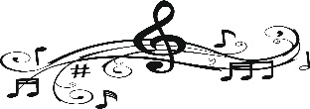I keep a close watch on this heart of mine;
This Photo by Unknown Author is licensed under CC BY-NC
I keep my eyes wide open all the time
I keep the ends out for the tie that binds
Because you're mine, I walk the line.

Jesus is mine! I am His! I desire to walk where He wants me to walk!
God's eyes are everywhere always, so that he never misses one single opportunity anytime, anywhere to demonstrate his power on behalf of weak people who rely on him and not man.
God Sees Hearts as We See Faces!
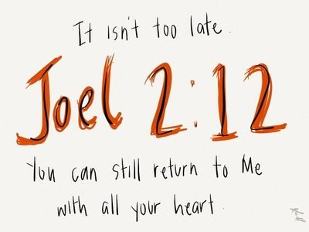

HEART CARE IS THE RESPONSIBILITY OF EACH OF US. We should “keep a close watch on our hearts and place ourselves in full view of God.”
First…seeing ourselves in the mirror of our soul,
Second…Understanding that our hearts are in tune with God only when we let Him remold and make our lives and our living to be more like Jesus.
Last…Pleasing God is changing our heart to fit His plan for our lives.

Pray for an anointing of God!
