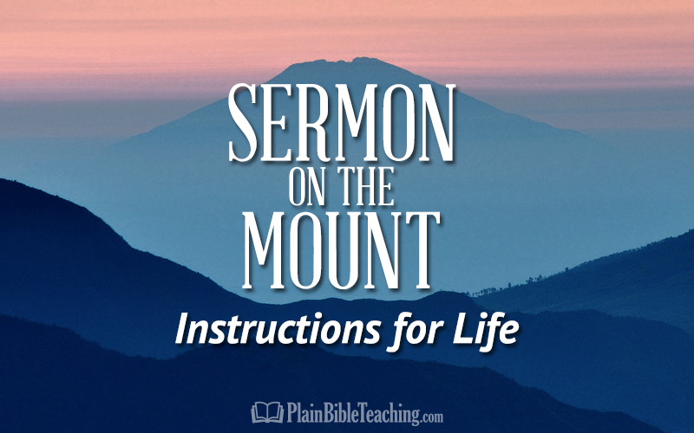

The “Ifs” in the Book of Matthew
By Gerald Cumby
If you want to know the Power of God, read the Word of God, study the Word of God, and “Do” the Word of God!
There are 74 “if” statements in Matthew; Jesus used the term more than any other character talked about in Matthew.
Some information about Matthew:
- Matthew was writing to the Jews of his time.
- The church was not on his mind…his fellow brothers were.
- Most of his writing came from his notes as he traveled with the Messiah.
- You would think he would be the last to acknowledge and be concerned about his Jewish friends.
- But wait…he had few, if any, friends.
- He was a tax collector (hated by his own people).
- At the time Matthew was called to be an Apostle, he was a successful tax collector for the Roman Government.
- Matthew called himself “a publican” in Matthew 10:3, which was what Jews called tax collectors. This was called a despicable, dishonest job and showed disloyalty to the Nation of Israel.
- “Even though some publicans like Matthew were not dishonest, the Jews looked upon all as hated sinners.
- For Matthew to admit in his Gospel that he was a publican showed that he was a humble man.
- He didn’t want to give the wrong impression of his past and wanted instead to show the transforming influence of the Lord’s spirit.”
Matthew was a man who had been touched by Jesus. He had been a man with an arrogant spirit of a tax collector, but turned (showing true repentance) into a man with a tender and humble spirit.
I know of only one power that can transform a life of arrogance, rebellion, selfishness, and pride into a person with a humble spirit and a tender and compassionate heart. The Spirit of God working in a person who chooses life and learning to walk in God’s grace and mercy.
Counsellors, Psychiatrists, and doctors with a “pedigree and pedigra” in mental and emotional health can’t do what Jesus can do through the power of the Spirit. God’s power far surpasses man’s highest ideals of helping people deal with depression, loneliness, physical malformities and terrible disease. God’s healing has been bought and paid for by His Son, Jesus.
Matthew was a man whose heart had experienced an awakening and he had to write about what he knew as truth.
At this time, I have to ask myself and those who are part of this study.
Do we know the healing power of repentance…admitting our faults, our shortcomings, our sins?
Do we know without a doubt…that Jesus wants and desires all of us (inner and outer parts) in order for Him to establish a great work in and through us?
- Matthew was astonished at the accomplishments of Jesus.
- He, of all the disciples, felt blessed and privileged to be a part of Jesus’ ministry.
- He kept notes of the healings, the miracles, and the details of all Jesus had to say and do as he walked from place to place.
- He probably felt like he was an outsider amongst the crowds that followed Jesus, especially the other 11 disciples who were called by Jesus to “Come and follow me (Jesus).”
- Matthew was a prolific writer (many writings). However, he combined his writings to produce the Gospel according to Matthew.
The little word “if” was used by Jesus and many of his followers…especially the ones who were needing a touch from Jesus (physically, emotionally/mentally, spiritually).
Listen…as Matthew uses these little “ifs” to explain some wonderful truths in his gospel.
The “Ifs” for healing:
Matthew 8:2-3, “A man with leprosy came and knelt before him and said, “Lord, if you are willing, you can make me clean.” ³ Jesus reached out his hand and touched the man. “I am willing,” he said. “Be clean!” Immediately he was cleansed of his leprosy.”
Matthew 9:21-22, “She (the woman with the issue of blood) said to herself, “If I only touch his cloak, I will be healed.” ²² Jesus turned and saw her. “Take heart, daughter,” he said, “your faith has healed you.” And the woman was healed at that moment.
Chapters 8 and 9 proceed to give some of the instances of the miracles Jesus performed, which proved and is still proving Him to be a Teacher come from God, as well as a healer of a diseases in a corrupt world.
- Here we see the cleansing of a leper, the curing of a palsy and fever, and a communication discourse with two of His disciples.
- We also see near the end of the chapter the true power of our Savior and Lord.
- We see Jesus calming the sea (He even has control of nature) and
- See Him casting out devils (He has control of the physical and mental faculties….even in control of Satan’s dominion over man).
- He only did what God had given Him authority to do.

Remarkable instances of the power and compassion of the Lord Jesus can be seen in Chapter 9:
- He was able to save to the uttermost all that come to God by Him.
- Jesus cured and healed the sick, raised the dead (ruler’s daughter),
- Gave sight to the blind and
- Cast out the devil of a possessed man.
- He also forgave sins,
- Called Matthew out to be His disciple,
- Conversed freely with sinners.
- He reiterated the importance of fasting
- Showed compassion on the multitudes.
He did this as the Great Physician (both of body and soul) and, in turn, addresses our need to follow and glorify Him both in body and spirit.
The “Ifs” for Forgiving
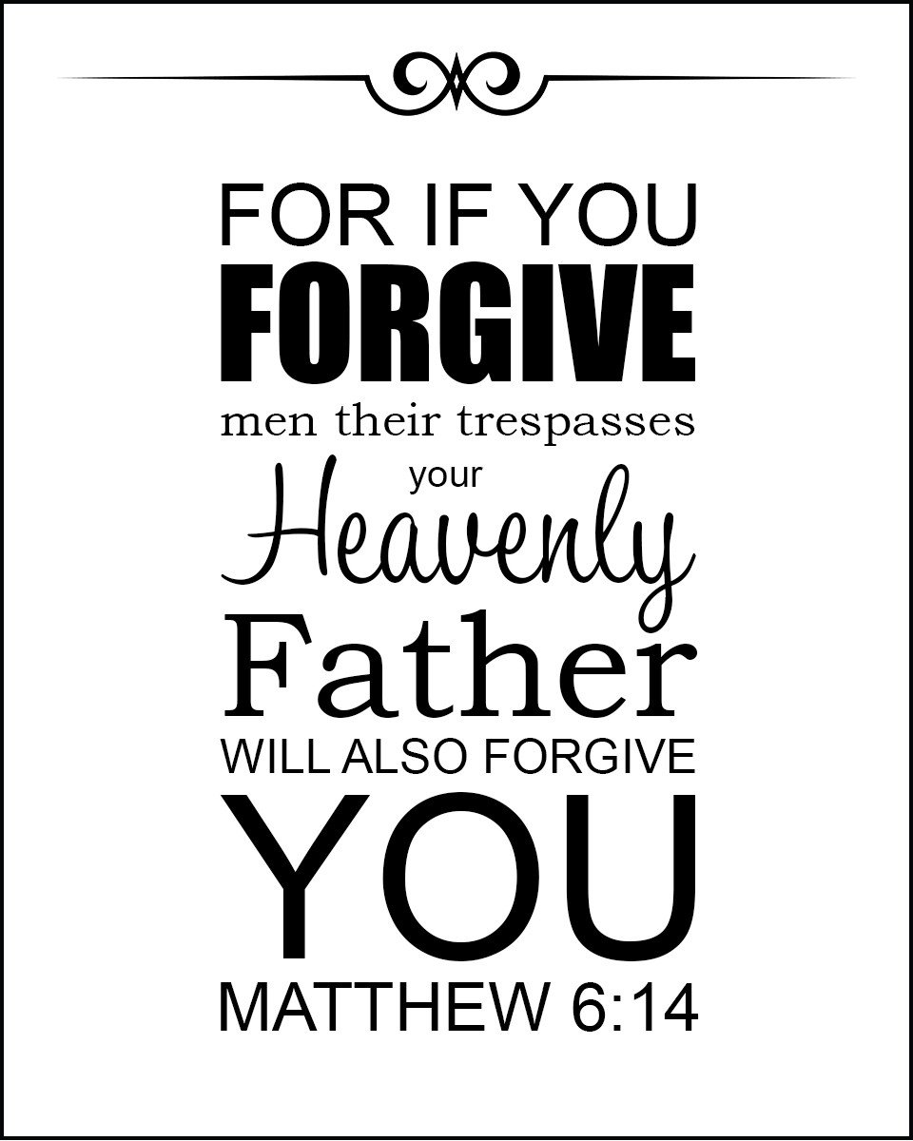
Matthew 6:15, “But if you do not forgive others their sins, your Father will not forgive your sins.”
One of the hardest Scriptures in the Word of God for the believer should be the easiest Scripture to understand and take heed.
We have been forgiven for much…so very much! Our hearts should be tender to the touch.
What would happen if we would forgive those who have trespassed against us as God has forgiven us who have trespassed against HIM?
This chapter of your life…Why not???
The M&Ms for Living…
Minimize regrets; Maximize your faith; Mend broken relationships; Meditate on Worthwhile Memories; Maintain a Balanced Life in Your Quest to Finish Strong; Move into the Right Lane to Finish the Course; and…Make adjustments to receive your reward!
Notes for the Teacher:
This Photo by Unknown Author is licensed under CC BY-SA
- Matthew was very adamant, yet very skillful in promoting Jesus as the Messiah as foretold by the Old Testament Prophets.
- Matthew quoted from the Old Testament repeatedly because his audience was mainly Jewish readers.
- Matthew did not quote from the Old Testament to prove a point or belittle the Pharisees and Sadducees. His (Matthew) interest was to simply address the parallel between the prophesied King of Israel in the Old Testament and that of Jesus, who was the Lion of Judah, the Davidic Covenant King who would eventually set up His Kingdom on earth.
- Little did Matthew know that his work is probably the most widely read book in the entire world (not proven but accepted as a probability by many scholars).
If we could have walked with Jesus as Matthew did, watched Him play, watched Him pray, watched Him heal the sick, watched Him raise the dead, watched Him fulfill all the Scriptures, watched Him die, observed His resurrected body in the flesh, heard Him as Risen Lord, and watched Him ascend into heaven….then we, too, would be humbled to the point of wanting all the world to know that we are nothing without the One who gave His All….Jesus truly was and is who the Scripture said He was and is…He truly is the I AM…the King of Kings!

