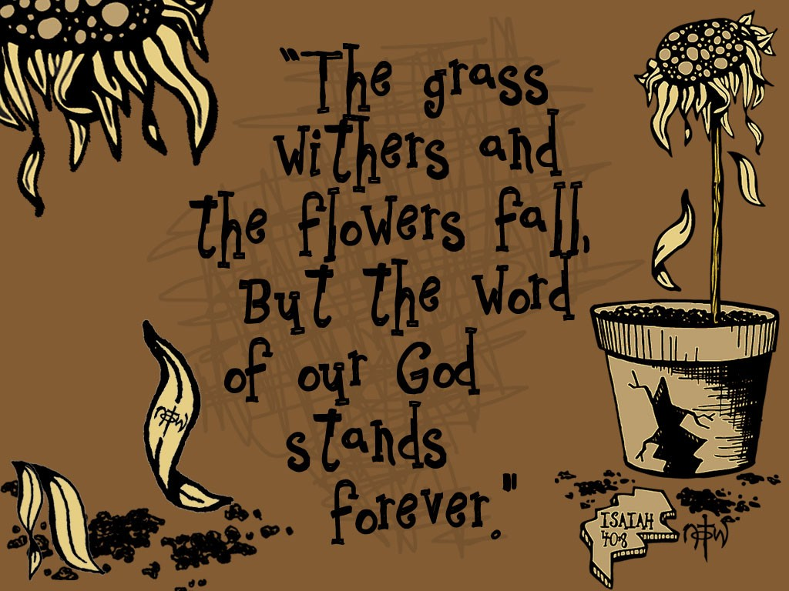

“IF” Series –Lesson #5
By Gerald Cumby

If…The Little Big Word!
A word with power to transform or tear down.

The word ‘if’ is interesting. It is one of the most important words in the Bible because it speaks directly to our responsibility to God.
Again… “IF YOU WILL, I WILL!” GOD SAYS.

“IF” is a word that stands between a man’s entrance into heaven or hell!
If you believe…heavenly reward. If you do not believe…eternal damnation!
"But as for the cowardly, the faithless, the detestable, as for murderers, the sexually immoral, sorcerers, idolaters, and all liars, their portion will be in the lake that burns with fire and sulfur, which is the second death.” Revelation 21:8
"And do not fear those who kill the body but cannot kill the soul. Rather fear him who can destroy both soul and body in hell." - Matthew 10:28
"And these will go away into eternal punishment, but the righteous into eternal life.” - Matthew 25:46
The Promise Can be a “Reward” or a “Discard.”
Accepted as a Son with all the benefits of such….or, Thrown away as chaff into a fire…

Revelation 22:18-19, “For I testify to everyone who hears the words of the prophecy of this book: If anyone adds to these things, God will add to him the plagues that are written in this book; and if anyone takes away from the words of the book of this prophecy, God shall take away his part from the Book of Life, from the holy city, and from the things which are written in this book.
The Word of God is so very important to all who respect and revere God and His Son, Jesus the Christ…and understand the importance of the Holy Spirit living in us.
GOD’s Word is Truth/Fact and must be handled carefully and reverently when we give our interpretation of His Word (Scripture).

If we believe that the Word of God is “God breathed” and “Inspired” by God Himself…without flaws (without mistakes), then would it not be in our interest to not only believe, but also react to its “DOs and don’ts” accordingly?
Our acts of repentance…and our actions to prove our love for HIM are important….No, they are imperative!

There are so many different versions and translations of the Bible, along with editions (changes in wording) of the 1st version or translation, that we congregants and sojourners are sometimes “confused” as to which one to use as the best interpretation of the original.

John gives a final warning for those who might tamper with this prophecy (Rev.22:18)
“For I testify to everyone who hears the words of the prophecy of this book: If anyone adds to these things, God will add to him the plagues that are written in this book;…”

NOTE:
- On the one hand, God promises a blessing to those who read the prophecy in Revelation:
Revelation 22:6, “The angel said to me, “These words are trustworthy and true. The Lord, the God who inspires the prophets, sent his angel to show his servants the things that must soon take place.”
⁷ “Look, I am coming soon! Blessed is the one who keeps the words of the prophecy written in this scroll.”
- On the other hand, to those who reject the revelation of this book, He gives a double warning.
- God gives a warning to those who would undermine the Word of God.
- He warns of special judgment to those who do so.
There will be a strong delusion in the future. We need God’s Word to know what we believe.
Delusion = something that is falsely or delusively believed or propagated; the act of tricking or deceiving someone.
“For the mystery of lawlessness is already at work; only He who now restrains will do so until He is taken out of the way. And then the lawless one will be revealed, whom the Lord will consume with the breath of His mouth and destroy with the brightness of His coming. The coming of the lawless one is according to the working of Satan, with all power, signs, and lying wonders, and with all unrighteous deception among those who perish, because they did not receive the love of the truth, that they might be saved. And for this reason God will send them strong delusion, that they should believe the lie, that they all may be condemned who did not believe the truth but had pleasure in unrighteousness” (2 Thessalonians 2:7-12).
The Holy Spirit is the restrainer. The Holy Spirit is the one that convicts and convinces the sinner of the error of his ways.
Without the Holy Spirit to convict…it leaves condemnation and death.

Revelation 22:19, “And if anyone takes away from the words of the book of this prophecy, God shall take away his part from the Book of Life, from the holy city, and from the things which are written in this book.”

The first warning is a warning to those who take away the words of this prophecy.
If they do this:
- God will take away their “part in the Book of Life,
- God will take away their entrance into the holy city, and
- God will take away from the blessings/blessings and promises which are written in this book.”
To tamper with the Word of God is to reject God Himself. When someone rejects any part of the book of Revelation, God will take away his/her part from the Book of Life (Wipe the slate clean…like he never existed)…BUT, his soul and spirit will be forever separated from God in hell.

If we tamper with God’s book, He will tamper with our book! (The story of our life will be no story at all.)
The Word of God is our only source for understanding the nature of salvation.
- When a person rejects the Source of salvation…he rejects the only way to the Father…God Almighty!
- This is a terrible penalty.
Note: This penalty is unretractable and is worse than a life sentence in a penitentiary. It is punishment beyond description.

The Application of this Truth from God’s Word:
- God will weed out those who play with His Word.
- God gives strong warnings against tampering with the Word of God.
- We dare not add to or subtract from the Word of God.
- Both are grave issues with God.
In Genesis 3:2, Eve made the mistake of adding the phrase “nor touch it” to God’s warning about eating from the Tree of Knowledge.
Genesis 3:1-2, “Now the serpent was more crafty than any of the wild animals the Lord God had made. He said to the woman, “Did God really say, ‘You must not eat from any tree in the garden’?” ² The woman said to the serpent, “We may eat fruit from the trees in the garden, ³ but God did say, ‘You must not eat fruit from the tree that is in the middle of the garden, and you must not touch it, or you will die.’”
Eve’s grave mistake:
- By making the commandment seem stricter (more difficult to keep) than it really was, she betrayed her suspicions about God and His goodness.
- Insulting His majesty this way was the first step on her road away from God.

Some other Scripture truths about the importance of holding on to God’s specific word and not adding to or taking away from the Holy “God Inspired” Scriptures:
“You shall not add to the word which I command you, nor take from it, that you may keep the commandments of the Lord your God which I command you” Deuteronomy 4:2).

“Whatever I command you, be careful to observe it; you shall not add to it nor take away from it” (Deuteronomy 12:32).
Believers…Changing the Word of God to fit our narrative or our need is like the two types of gas: CO (Carbon Monoxide) and CO2 (Carbon Dioxide). …Carbon dioxide is important in the process of respiration and photosynthesis. Carbon monoxide at increased levels is poisonous which will likely result in death.
There is a great contrast between the lot of the lost and that of the believer.
“Blessed is he who reads and those who hear the words of this prophecy, and keep those things which are written in it; for the time is near” (Revelation 1:3).
DON’T MESS WITH GOD’S WORD!

